Screenshot 1:
Claude Code installed successfully.
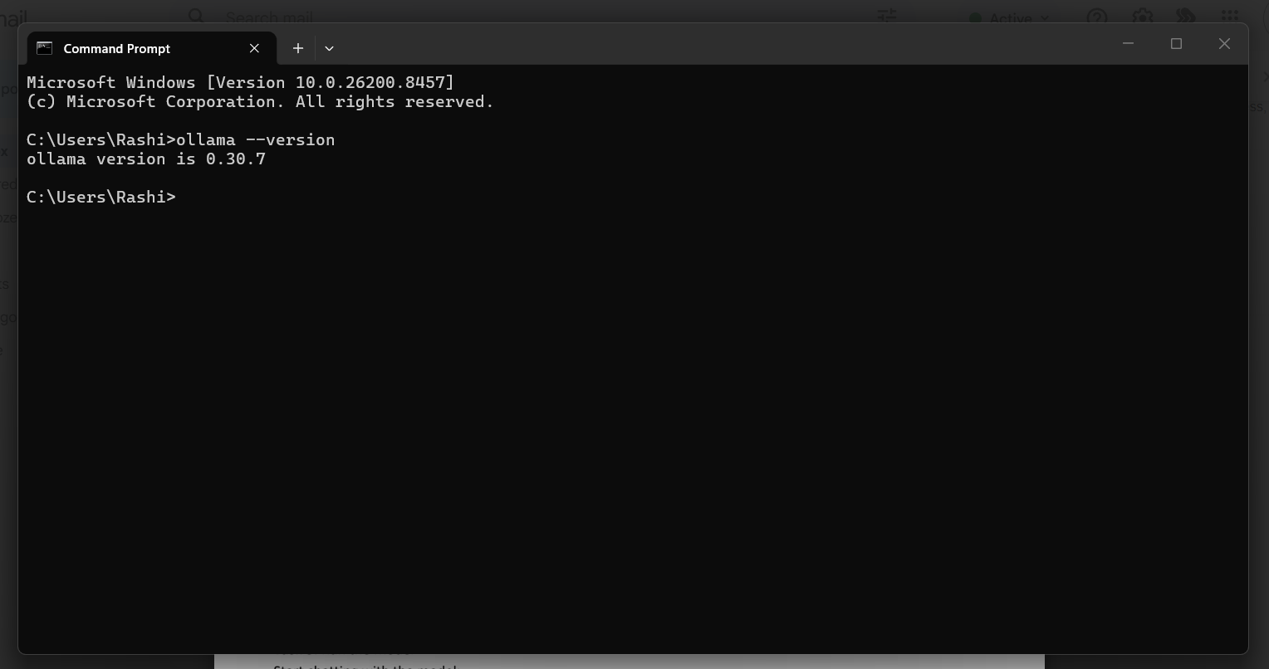
Screenshot 2:
Ollama installation verification.
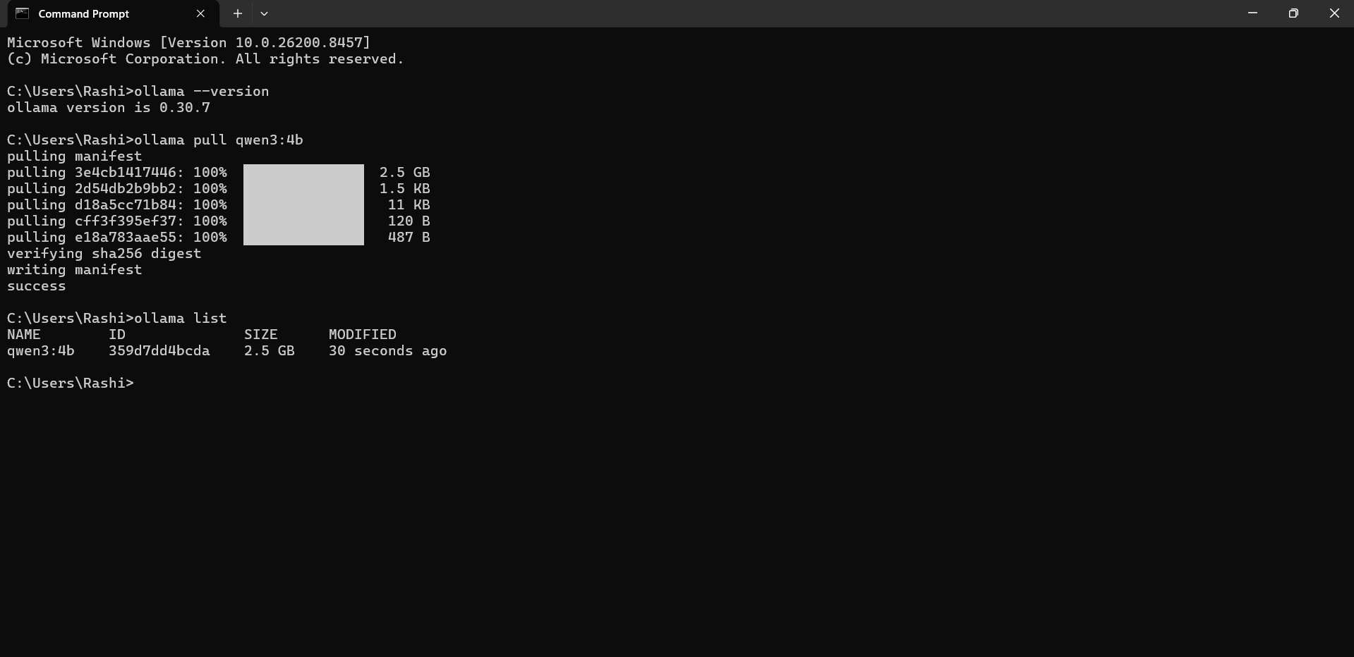
Screenshot 3:
Qwen model downloaded.
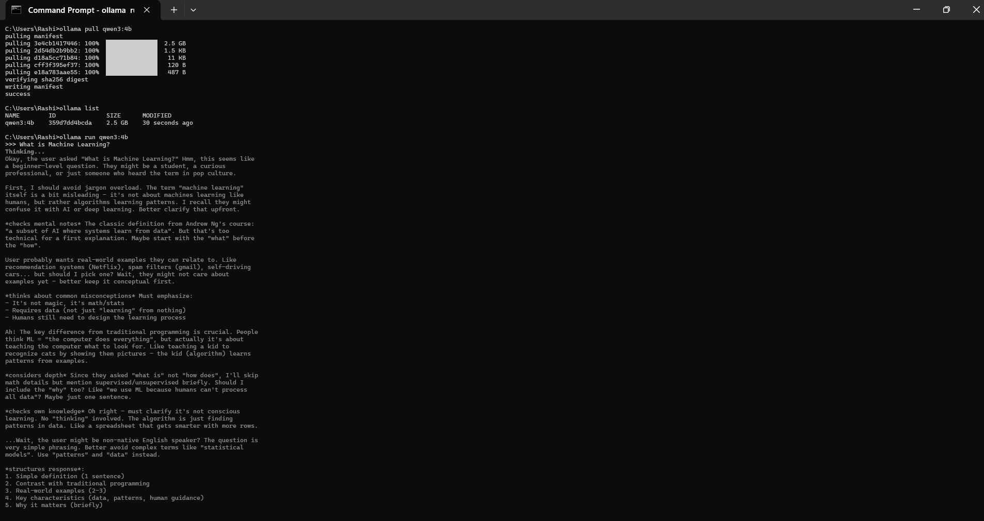
Screenshot 4:
Qwen model running in the terminal.
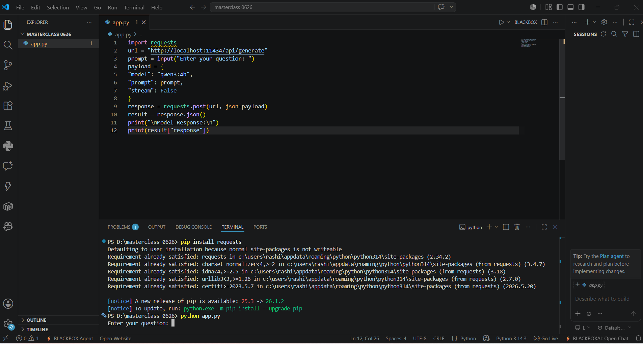
Screenshot 5:
Python code execution with model response.
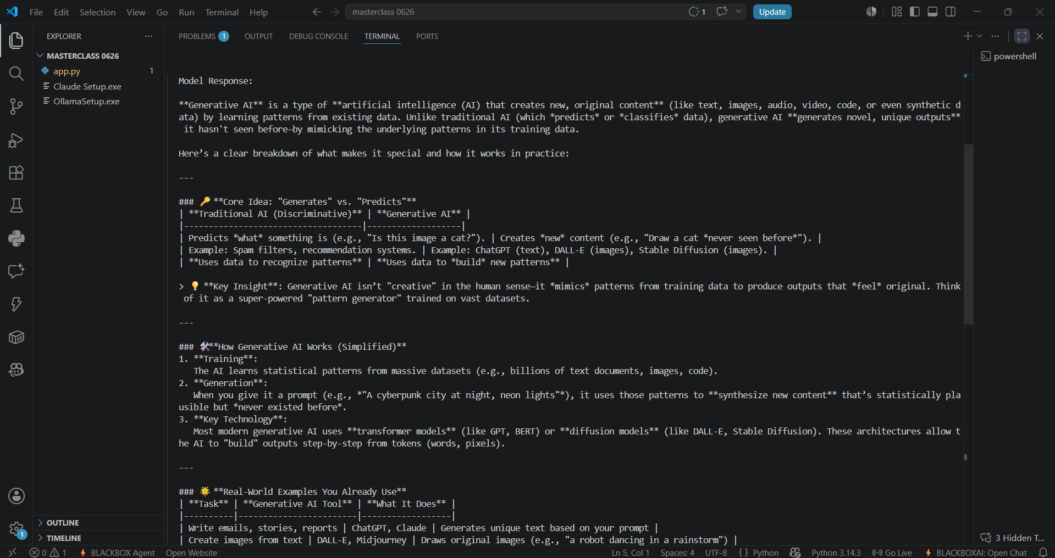
Screenshot 6:
GitHub repository showing uploaded code.
